**Description:** User should be logged into to Amazon web application with correct email id/phone and password.

1. Launch amazon application in chrome with url

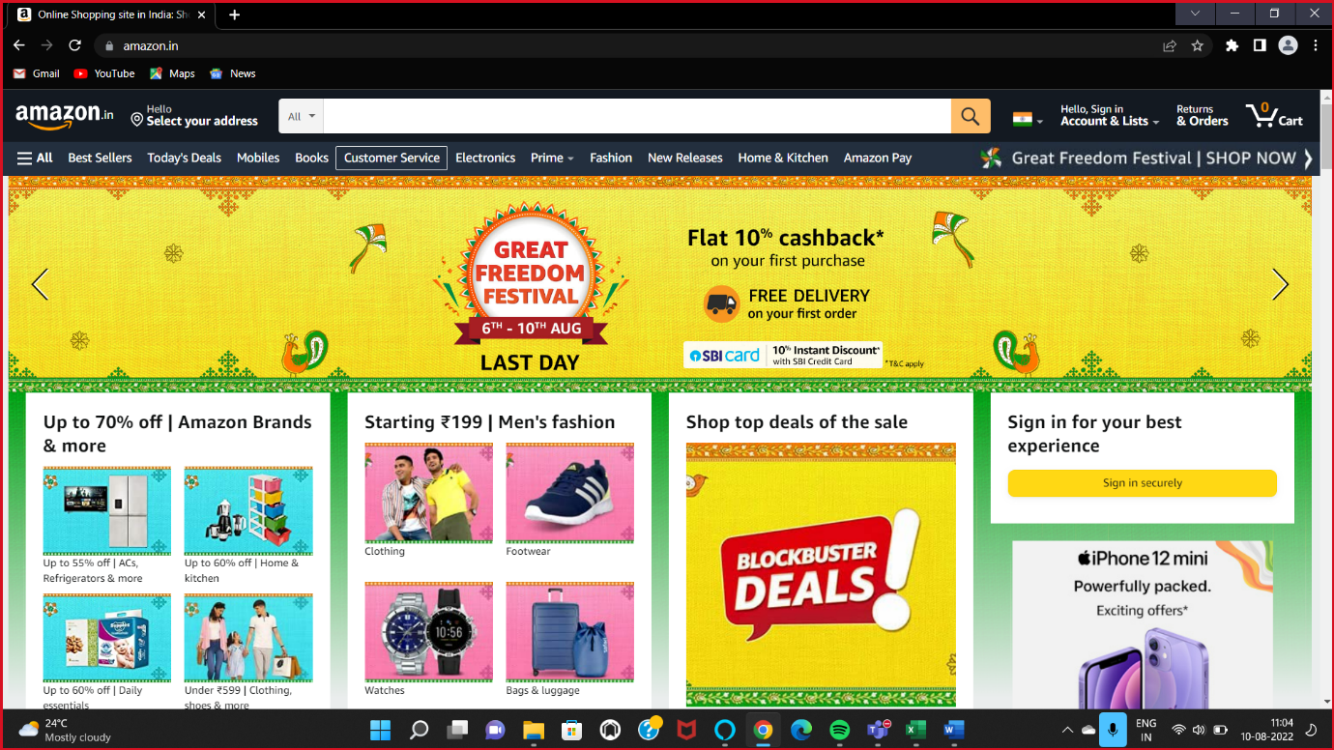

User clicks on Sign in button

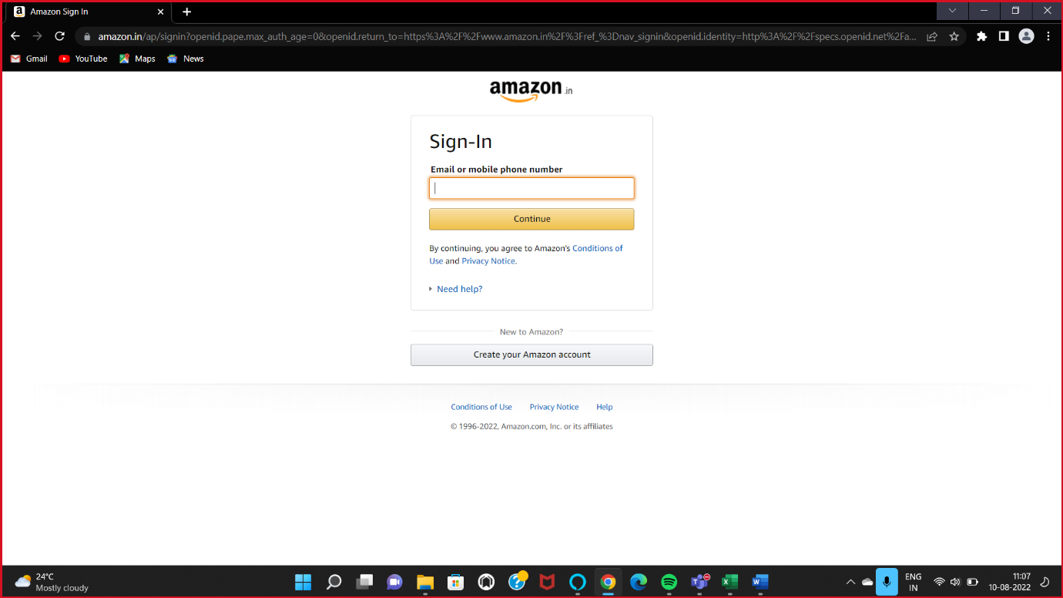

User enters email id-"abc@gmail.com" in username field and clicks continue

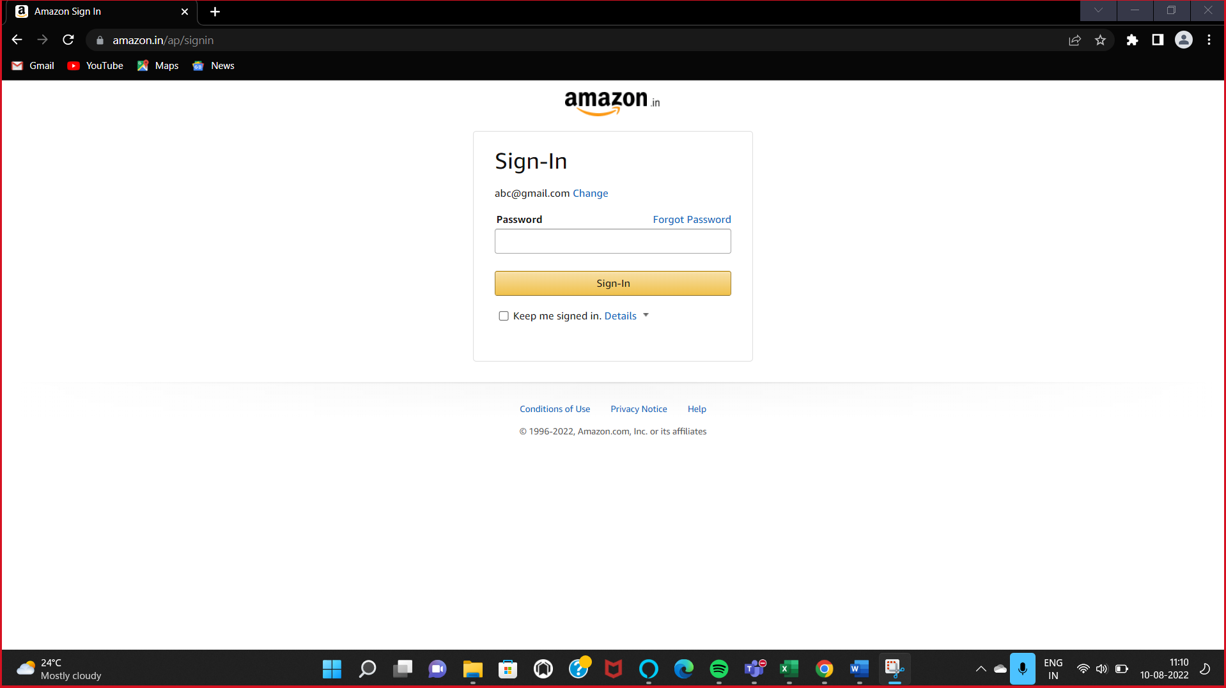

User enters password "**password@123**"in password field and clicks Sign in button

